Aboveground Storage Tank (AST)

New Tank System Installation/First Fill Inspection Checklist
Approved for use by the Agency of Natural Resources on XXXXX

Aboveground storage tank (AST) inspections are required by the Aboveground Storage Tank Rules (effective XXXXXX). Tank inspections are required to be conducted in accordance with Section 9-305 of the Rules. This checklist is to be completed by the person inspecting the tank.

Inspection Completed by:_______________________________ Company:_______________________________________

Tank Owner Info:
Name: | Address:
City/Town: | Phone/email:

12 GA Steel Single Wall ☐ | 12 GA Steel Double Wall ☐
Fiberglass Double Wall ☐ | Fiberglass Double Wall ☐
Double-wall tanks with Polyethylene or other plastic polymer inner wall and metallic outer wall☐
Other Type:______________________________________________
Type of Tank

Tank Location: ☐ Indoor ☐ Outdoor Is tank located in a flood prone area? ☐YES ☐ NO

Date of Tank Install: (Date of Installation Must be Visibly Identified on Tank)

COMPLETE AFTER TANK INSTALLATION BUT BEFORE FIRST FILL:  (The number at the end of each question refers to the tank diagram on page 2 of this checklist) | NA | YES | NO
Is the tank installed on a concrete pad at least 4 inches thick and a footprint exceeding dimensions of tank by at least 10%? (1)  Check NA only if an alternative foundation has been approved by the Agency in writing.  Provide Date of Approval ________________________________________ | ☐ | ☐ | ☐
Are piping and fuel lines that are in direct contact with earthen materials or concrete, coated and sleeved to protect against corrosion and damage? (2)  Check NA only if pipes and fuel lines are not in direct contact with earthen material or concrete. | ☐ | ☐ | ☐
Is the vent line equipped with an overfill vent alarm that is within 12 feet of the fill pipe and visible from the fill pipe? (3) |  | ☐ | ☐
Is the fill and vent line diameter a minimum 1¼ inches and is the fill piping made of metal materials permitted by NFPA 31? Are fill and vent pipes fitted with appropriate caps? (4) |  | ☐ | ☐
Is the entirety of tank surface and legs free of any cracks, significant corrosion, pitting, rust, spores, dents and bulges? (5) |  | ☐ | ☐
Does the tank have a shut-off valve within 12 inches of the AST fuel outlet? OR If tank draws fuel from the top of tank, is the shutoff valve installed before the fuel filter? (9) |  | ☐ | ☐
Are all unused openings plugged/closed? |  | ☐ | ☐
Are all tank legs no longer than 14 inches in length? (8)  Check NA only if longer legs were approved by the Agency in writing.  Provide Date of Approval ___ | ☐ | ☐ | ☐
Does the tank have an operational fuel level gauge? (7) |  | ☐ | ☐
 | NA | YES | NO
For tanks with Double Wall Protection: is the tank equipped with a functional interstitial leak detector? Does the leak detector indicate tank is OK? |  | ☐ | ☐
For outdoor tanks: is the tank protected from hazards (falling ice and snow from roof)? (6)  Leave response blank for indoor tank. |  | ☐ | ☐
For indoor tanks- is tank located on the lowest floor of the structure?  Check NA only if the tank is NOT located inside a structure OR if an alternative location has been approved by Agency in writing. Provide Date of Approval ________________________________________________ | ☐ | ☐ | ☐
If there are multiple tanks, does each tank either have a separate fill and vent pipe or have a  separate fill but manifolded vent pipe? Check NA only if does not apply. | ☐ | ☐ | ☐
For tanks located in flood prone areas: is the tank anchored to concrete pad or alternative preapproved foundation and is the vent pipe of sufficient length to extend above projected flood level? Check NA only if tank is NOT located in a flood prone area OR if you received written exemption from this requirement form the Secretary. | ☐ | ☐ | ☐

STOP! If any responses to the above questions are “NO”, the tank has not been installed in compliance with the Vermont AST Rules and cannot be filled. Unless the out-of-compliance issues can be addressed immediately, the tank must be Red Tagged.

COMPLETE AFTER FIRST FILL FOR NEW INSTALLATIONS ONLY: | YES | NO
Is the system free of drips, leaks, or other evidence of a release? | ☐ | ☐
Did the vent alarm function during the delivery? | ☐ | ☐

If any responses to the above questions are “NO”, the tank has not been installed in compliance with the Vermont AST Rules and must be Red Tagged unless the out-of-compliance issues can be addressed immediately.

CERTIFICATION STATEMENT

I, _______________________________, as the inspector of
(Print name and company)

this AST do certify that the new installation located at _________________________________________________________
^{(Property address)}
was inspected on: __________________and was found to be ☐ In Compliance with standards specified in 2024 VT AST rules.
^{(Date)} ☐ Not in Compliance

(Signature of certified tank inspector) (Date)

The tank inspector is required to provide a copy of this completed checklist to the tank owner within five business days of the date of inspection. A copy of the completed checklist shall also be retained by the tank inspector for three years and shall be presented to the Agency of Natural Resources upon request.
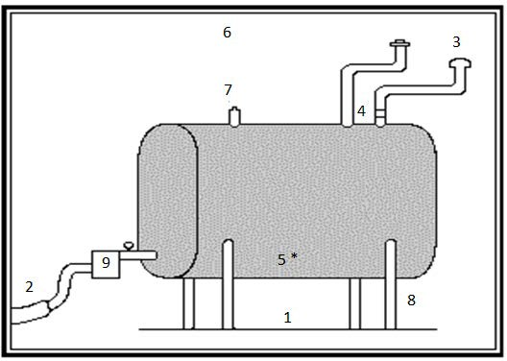

DISCAIMER: This inspection checklist has been developed to assist in performing AST inspections pursuant to the AST Rules, effective XXXXX. A full description of inspection requirements and other compliance information can be found in the Rules, located here: LINK

ANR Contact Information:

Main Office # 802‐828‐1138

Hazardous Materials Program Manager: Anna Bourakovsky (802) 477-2981

Storage Tanks Section Supervisor: Michael Nahmias (802) 522-4595

ANR Storage Tanks web page: http://dec.vermont.gov/waste‐management/storage‐tanks

